Week 1 Reference Sheet | 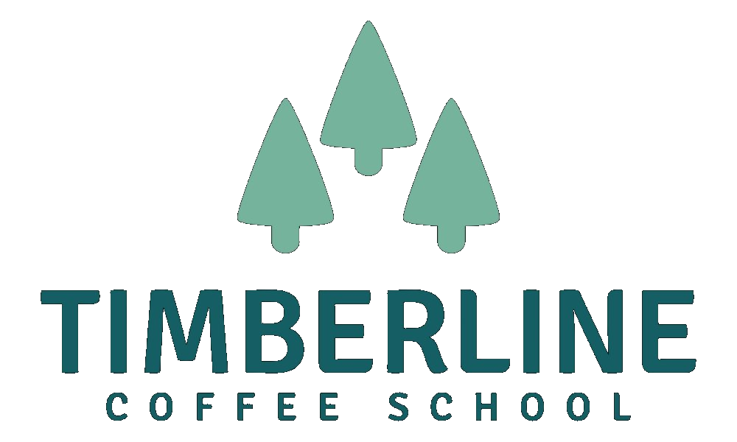

The Six Coffee Shop Models
Not all coffee shops work the same way. Each model below has its own setup costs, day-to-day demands, and type of customer. Read through all six before deciding which one fits what you’re building. There is no right answer — but there is a wrong one, and it’s the one you choose without thinking it through.
Shop Type | What you need to know
Neighbourhood Café | A sit-down shop built around community. People come in, stay a while, and come back regularly. The experience — the feel of the room, the staff, the regulars — is as important as the coffee.  What makes it work: Strong location with foot traffic or a loyal local community. Consistent quality and staff who make people feel known. A space that feels genuinely welcoming, not designed to push people out quickly.  Honest note: This model lives and dies by its lease. Rent is your biggest cost and your biggest risk. You also need enough seats and enough volume to cover the hours. Slower mornings can hurt.  Best for: Owners who want to be at the centre of their community and are in it for the long term.
Specialty / Third Wave | Coffee is the main event. Single-origin beans, careful sourcing, skilled baristas, and brewing methods that highlight what makes each coffee different. The bar is high — and intentionally so.  What makes it work: Deep knowledge of coffee and sourcing. Baristas who know how to talk about what they’re making without making people feel judged. A customer base that is willing to pay more and slow down.  Honest note: This model can struggle in markets that aren’t ready for it yet. It also takes longer to build volume because the average transaction is higher but the total number of customers is often smaller. Harder to scale quickly.  Best for: Owners with a genuine passion for coffee craft who want to be known for quality above everything else.
Grab-and-Go | Fast service, small footprint, and high volume. Customers come in, order, and leave — often in under three minutes. The menu is tight, the workflow is efficient, and the location is everything.  What makes it work: The right location: commuter routes, office buildings, transport hubs. A streamlined menu that can be made quickly and consistently. Very well-trained staff who can keep the line moving.  Honest note: Margins are thin because average spend is low. You need volume to make the numbers work, which means you are completely dependent on foot traffic. If the foot traffic goes away — roadworks, a new competitor, a change in commuting patterns — so does your income.  Best for: Owners who want simplicity, speed, and a tight operation. Less about atmosphere, more about efficiency.
Drive-Through | Customers order and collect without leaving their car. High volume, fast service, and very loyal regulars once you’re established. Often runs lean on staffing relative to revenue.  What makes it work: The right site with good access and space. A smooth, fast workflow at the window. A menu customers can order quickly without thinking too hard. Strong morning traffic.  Honest note: The setup costs are high — site, equipment, and build-out can be significant. You are also dependent on car culture in your area. Not right for dense urban locations. Permitting can be complicated.  Best for: Owners with some capital behind them and a clear suburban or rural market. Works especially well in commuter-heavy areas.
Hybrid: Café + Food | Coffee anchors the business but food — pastries, a small kitchen menu, a bakery element — adds revenue and extends dwell time. Customers come for coffee and stay (or return) for food.  What makes it work: A food offer that genuinely fits the concept and the space. Good supply relationships or in-house production. Staff who can handle both coffee and food service. Enough kitchen or prep space.  Honest note: Running food alongside coffee doubles the operational complexity. You now have two things that can go wrong, two sets of costs, and two things to train staff on. Margins on food are often lower than people expect. This model rewards operators who are genuinely good at both.  Best for: Owners who love both coffee and food and have experience (or a strong partner) in food service. Not ideal for first-time operators unless the food is very simple.
Co-working Café | A space designed for people to work from, not just visit. Fast Wi-Fi, good seating, ample power points, and an environment that supports focus. Coffee is the product but the workspace is the draw.  What makes it work: A space that is genuinely set up for working: good Wi-Fi, enough sockets, seating that is comfortable for a few hours. A culture where solo workers feel welcome. Often some kind of membership or day-pass model helps with revenue predictability.  Honest note: The challenge is that people who want to work tend to nurse one coffee for three hours. Revenue per seat-hour is low unless you manage it well. You need either volume, a membership structure, or a separate revenue stream to make it work. And you need to be careful not to become somewhere people feel awkward about.  Best for: Owners in areas with a strong remote-working population who want their shop to play a functional role in people’s days, not just a social one.
A note on mixing models: It is tempting to combine two or three of these into one shop. Sometimes that works — but only when the combination is deliberate and the operator knows what they are taking on. The most common mistake is accidentally becoming a hybrid by saying yes to too many things. Your Concept Brief is the tool that stops that from happening.
Timberline Coffee School — Opening Your Coffee Shop Cohort — Week 1

